**Python Module 4**

**Exercises:**

1. Manipulating strings:

• Given the string “Hello World!”, replace the first word “Hello” with the word “Hi”.

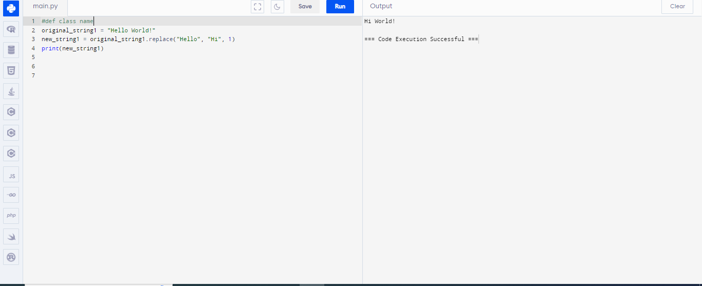

• Given the string “Hi, my name is John”, extract the word “John” from the string.

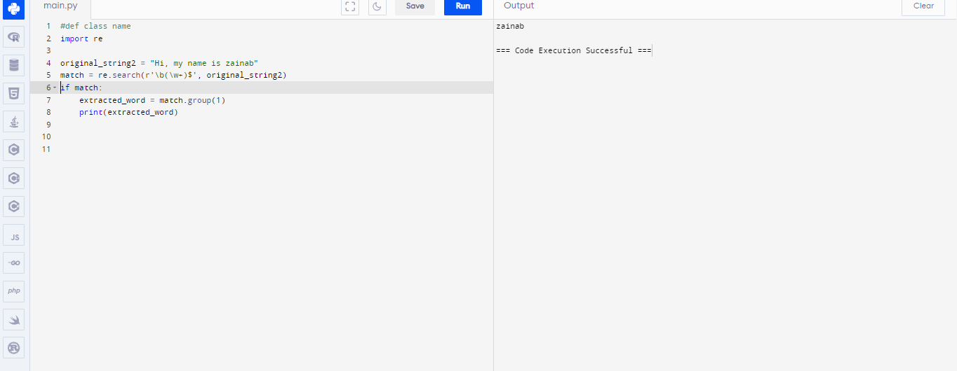

• Given the string “Hello, world!”, capitalize the first letter of each word.

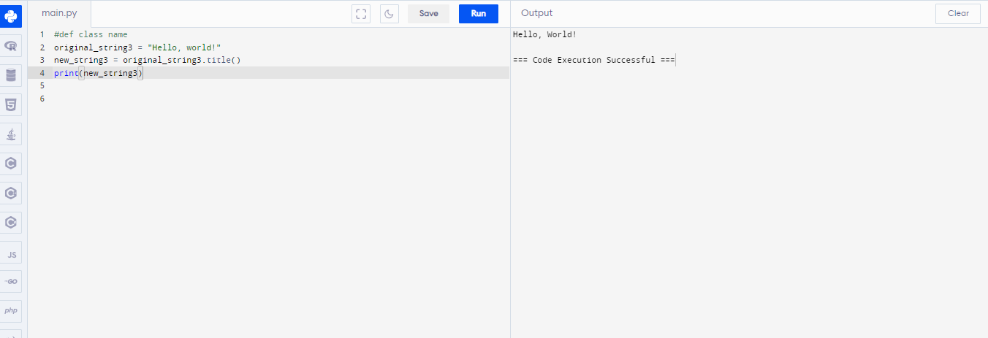

2. Formatting strings:

• Given the variables name = “John” and age = 30, create a formatted string that says “My name is John and I am 30 years old.” 8

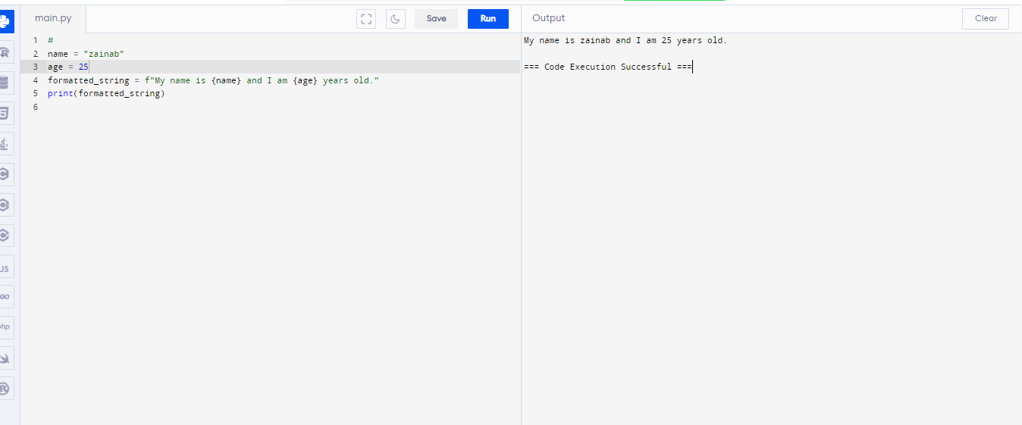

• Given a string “Today is January 1, 2021”, convert the date format to “01-01-2021”.

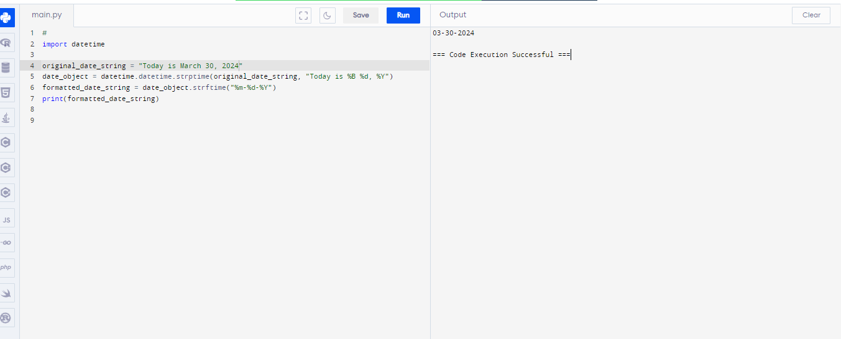

• Given a string “Python is a powerful language”, split the string into a list of words.

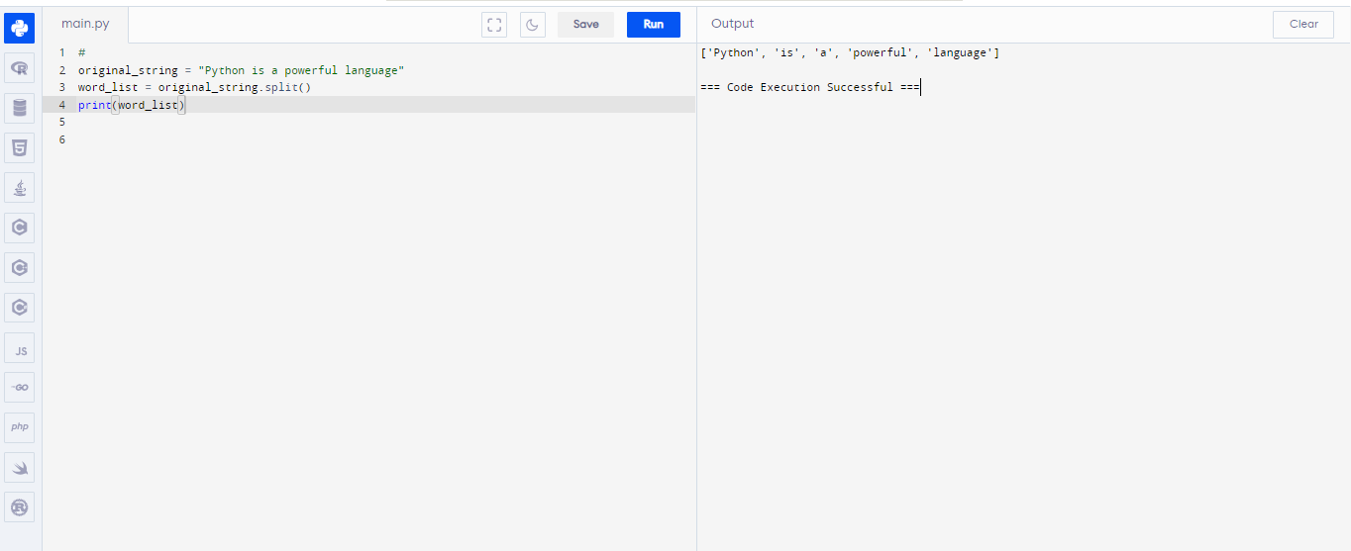

3. String methods:

• Given the string “Hello, world!”, count the number of times the letter “o” appears in the string.

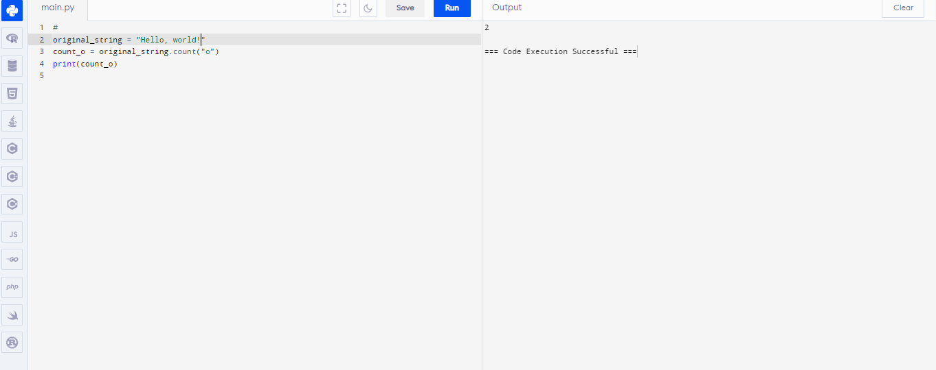

• Given the string “Hello, world!”, replace all occurrences of the letter “o” with the number “0”.

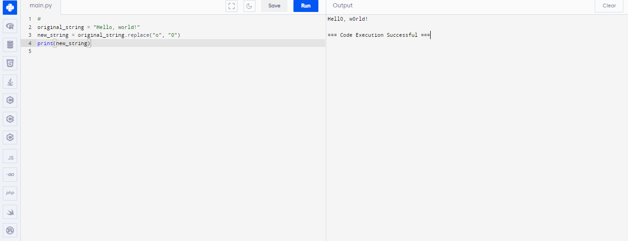

• Given the string “Hello, world!”, remove all whitespaces from the string.

